

**B.SC in Computer Science and Engineering**

Project Report

**DHAKA INTERNATIONAL UNIVERSITY**

**SoppingX an E-commerce website with Django**

*A comprehensive project report has been submitted in partial fulfillment of  
the requirements for*

**10th Semester**

*in***CSE410- Lab***Submitted to*

**Ass. Prof. K M Mohiuddin**



**Department of Computer Science and Engineering  
Dhaka International University**

**November, 2021**

**SoppingX an E-commerce website with Django**

**BY**

|  |  |
| --- | --- |
| **Name** | **Roll No.** |
| Nuzmul Hossain Nahid | 11 |
| Kabbo | 23 |

*A comprehensive project report has been submitted in partial fulfillment of  
the requirements for*

**10th Semester**

*in***CSE404- Peripherals and Interfacing Lab***Under the supervision of*

**Ass. Prof. K M Mohiuddin**



**Department of Computer Science and Engineering  
Dhaka International University**

**November, 2021**

**DECLARATION**

‘’We Do hereby declare that this submission is our own work conformed to the

norms and guidelines are given in the Ethical Code of Conduct of the Institute and that, to the best of our knowledge and belief, it contains no material previously written by another neither person nor material (data, theoretical analysis, figures, and text) which has been accepted for the award of any other degree or diploma of the university or other institutes of higher learning, except where due acknowledgment has been made in the text.”

|  |  |
| --- | --- |
| .......................................................... Joanna Ayonti Roll No: 09 | .......................................................... Nuzmul Hossain Nahid Roll No:11 |
| .......................................................... Nahid Hossain Roll No: 13 | .......................................................... **Maheem Mehedi** Roll No: 33 |

Date: 28-11-2021  
Place: Dhaka International University

Abstract

The main objective of this project is to develop a home automation system using an Arduino board with Bluetooth being remotely controlled by any Android OS smart phone. As technology is advancing so houses are also getting smarter. Modern houses are gradually shifting from conventional switches to centralized control system, involving remote controlled switches Google android operating system is one of the leading and most popularly preferred systems in smart phone.

Smart phone affordability increase day by day due to their size and portability android GUI installed in smart phone. The operator has to touch on the screen of the phone to control the home application. This project is an android application which possesses the capability to control any sort of electrical appliances providing remote access from smart phone using Bluetooth. Bluetooth technology is wireless radio transmission in a short distance providing a necessary technology to create convenience, intelligence and controllability. This generates personal area network in home environment. Where all these appliances can be interconnected and monitored using a single controller. Home automation involves a degree of computerized and automatic control to certain electrical and electronic system in a building. Busy families, individuals with physical limitation represent very attractive market for such networking. This system will also assist and support in order to fulfil the needs of elderly and disabled in home.

Table of Contents

|  |  |
| --- | --- |
| DECLARATION | 3 |
| ABSTRACT | 4 |
| CONTENTS | 5 |
| LIST OF FIGURES | 6 |
| INTRODUCTION | 7 |
| COMPONENTS REQUIRED | 7 |
| DESCRIPTION | 7-17 |
| BLOCK DIAGRAM | 18 |
| CIRCUIT DIAGRAM | 19 |
| SOFTWARE DESIGN | 19-20 |
| CODE | 21-23 |
| CONCLUSION | 23-24 |
| REFERENCE | 25 |

**LIST OF FIGURES**

|  |  |  |
| --- | --- | --- |
| FIG 1 | ARDUINO UNO R3 | PAGE 10 |
| FIG 2 | CHANNEL RELAY | PAGE 12 |
| FIG 3 | PIN DESCRIPTION OF BLUETOOTH MODULE | PAGE 16 |
| FIG 4 | BLOCK DIAGRAM OF HOME AUTOMATION SYSTEM USING ARDUINO AND BLUETOOTH MODULE | PAGE 18 |
| FIG 5 | CIRCUIT DIAGRAM OF HOME AUTOMATION SYSTEM USING ARDUINO AND BLUETOOTH MODULE | PAGE 20 |
| FIG 6 | Design of the software | PAGE 21 |

**INTRODUCTION**

We are living in 21st century where automation of any form i.e. home or industrial plays an important role in human life. When it comes to industrial automation, the concept is applied to large machines or robots which helps in increasing the efficiency in terms of production, energy and time.

Home automation on the other hand involves automating the household environment. This is possible because of the smartphones and internet that we are widely using. Home automation can be again divided in to just controlling the appliances using a smartphone from a remote location and another type filled with sensors and actuators which controls the lighting, temperature, door locks, electronic gadgets, electrical appliances etc. using a “Smart” system.

In this project, we will design a simple home automation project using simple components using which different electrical appliances can switched on or off. The project is based on Arduino and we have used Arduino UNO for the project.

**COMPONENTS REQUIRED**

1)ARDUINO UNO  
2)4 CHANNEL RELAY(5v)  
3)BLUETOOTH MODULE HC05  
4)POWER SUPPLY  
5)LOAD(BULB 220V)  
6)CONNECTING WIRES  
7)SMARTPHONE(BLUETOOTH ENABLED)

**DESCRIPTION**

1. **ARDUINO UNO:**

Arduino is an open source computer hardware and software company, project, and user community that designs and manufactures single-board microcontrollers and microcontroller kits for building digital devices and interactive objects that can sense and control objects in the physical and digital world. The project's products are distributed as open-source hardware and software, which are licensed under the GNU Lesser General Public License (LGPL) or the GNU General Public License (GPL), permitting the manufacture of Arduino boards and software distribution by anyone. Arduino boards are available commercially in preassembled form, or as do-it-yourself (DIY) kits. Arduino board designs use a variety of microprocessors and controllers. The boards are equipped with sets of digital and analog input/output (I/O) pins that may be interfaced to various expansion boards or Breadboards (*shields*) and other circuits. The boards feature serial communications interfaces, including Universal Serial Bus (USB) on some models, which are also used for loading programs from personal computers. The microcontrollers are typically programmed using a dialect of features from the programming languages C and C++. In addition to using traditional compiler toolchains,the Arduino project provides an integrated development environment (IDE) based on the Processing language project. The Arduino project started in 2003 as a program for students at the Interaction Design Institute Ivrea in Ivrea, Italy, aiming to provide a low-cost and easy way for novices and professionals to create devices that interact with their environment using sensors and actuators. Common examples of such devices intended for beginner hobbyists include simple robots, thermostats, and motion detectors. The name *Arduino* comes from a bar in Ivrea, Italy, where some of the founders of the project used to meet. The bar was named after Arduin of Ivrea, who was the margrave of the March of Ivrea and King of Italy from 1002 to 1014.

**Features of the Arduino UNO :**Microcontroller: ATmega328  
Operating Voltage: 5V  
Input Voltage (recommended): 7-12V  
Input Voltage (limits): 6-20V  
Digital I/O Pins: 14 (of which 6 provide PWM output)  
Analog Input Pins: 6  
DC Current per I/O Pin: 40 mA  
DC Current for 3.3V Pin: 50 mA  
Flash Memory: 32 KB of which 0.5 KB used by bootloader  
SRAM: 2 KB (ATmega328)  
EEPROM: 1 KB (ATmega328)  
Clock Speed: 16 MHz

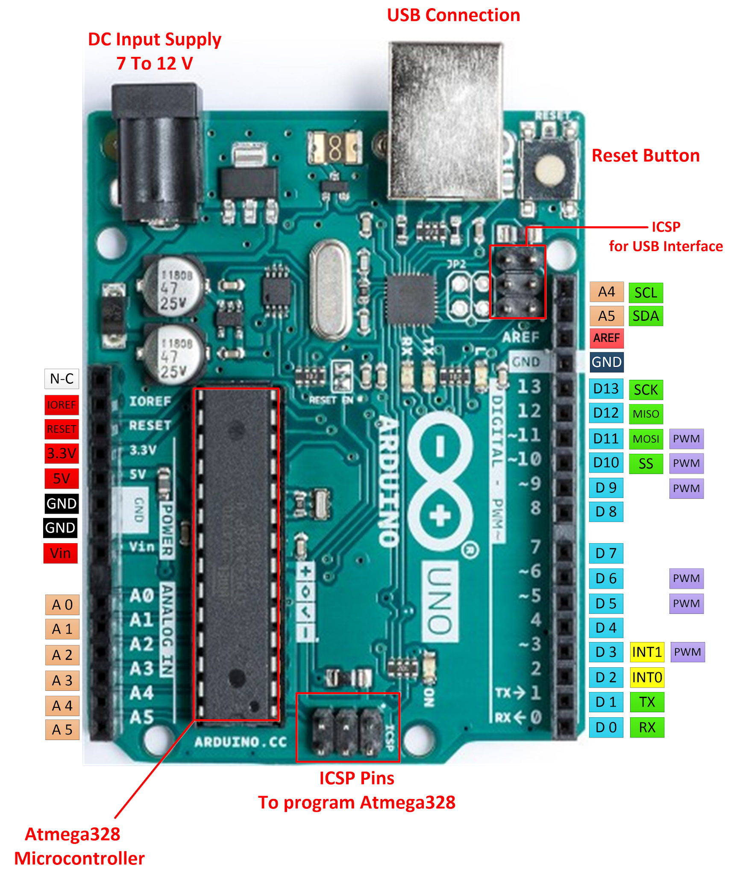

**FIG 1 ARDUINO UNO R3**

**2 .RELAY**

A relay is an electrically operated switch. Many relays use an electromagnet to mechanically operate a switch, but other operating principles are also used, such as solid-state relays. Relays are used where it is necessary to control a circuit by a separate low-power signal, or where several circuits must be controlled by one signal. The first relays were used in long distance telegraph circuits as amplifiers: they repeated the signal coming in from one circuit and re transmitted it on another circuit. Relays were used extensively in telephone exchanges and early computers to perform logical operations.

A type of relay that can handle the high power required to directly control an electric motor or other loads is called a contactor. Solid-state relayscontrol power circuits with no moving parts, instead using a semiconductor device to perform switching. Relays with calibrated operating characteristics and sometimes multiple operating coils are used to protect electrical circuits from overload or faults; in modern electric power systems these functions are performed by digital instruments still called "protective relays".

Magnetic latching relays require one pulse of coil power to move their contacts in one direction, and another, redirected pulse to move them back. Repeated pulses from the same input have no effect. Magnetic latching relays are useful in applications where interrupted power should not be able to transition the contacts.

Magnetic latching relays can have either single or dual coils. On a single coil device, the relay will operate in one direction when power is applied with one polarity, and will reset when the polarity is reversed. On a dual coil device, when polarized voltage is applied to the reset coil the contacts will transition. AC controlled magnetic latch relays have single coils that employ steering diodes to differentiate between operate and reset commands.

A type of relay that can handle the high power required to directly control an electric motor or other loads is called a contactor. Solid-state relayscontrol power circuits with no moving parts, instead using a semiconductor device to perform switching. Relays with calibrated operating characteristics and sometimes multiple operating coils are used to protect electrical circuits from overload or faults; in modern electric power systems these functions are performed by digital instruments still called "protective relays".

The Arduino Relay module allows a wide range of microcontroller such as Arduino, AVR ,PIC, ARM with digital outputs to control larger loads and devices like AC or DC Motors, electromagnets, solenoids, and incandescent light bulbs. This module is designed to be  
integrated with 2 relays that it is capable of control 2 relays.The relay shield use one QIANJI JQC-3F high-quality relay with rated load 7A/240VAC,10A/125VAC,10A/28VDC.The relay output state is individually indicated by a light-emitting diode.

4 channel relay features:  
Number of Relays: 4  
Control signal: TTL level  
Rated load: 7A/240VAC 10A/125VAC 10A/28VDC  
Contact action time: 10ms/5ms

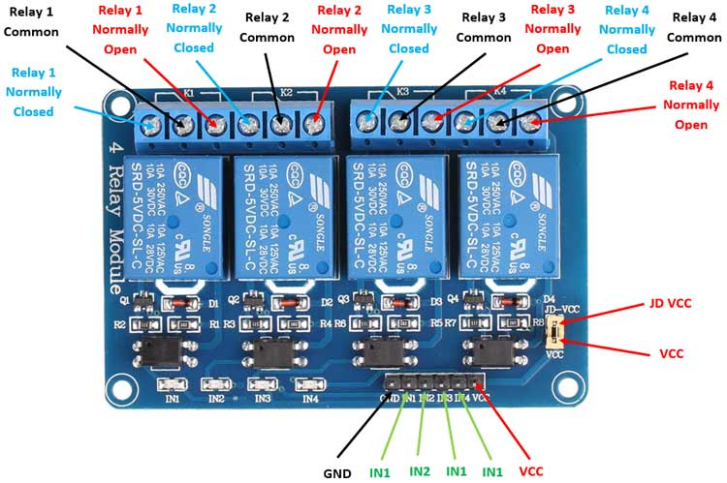

**FIG 2 CHANNEL RELAY**

**Circuit Schematic:**

For better understanding let’s see the circuit schematics of the relay module in this configuration. So we can see that the 5 volts from our microcontroller connected to the Vcc pin for activating the relay through the Optocoupler IC are also connected to the JDVcc pin which powers the electromagnet of the relay. So in this case we got no isolation between the relay and the microcontroller.

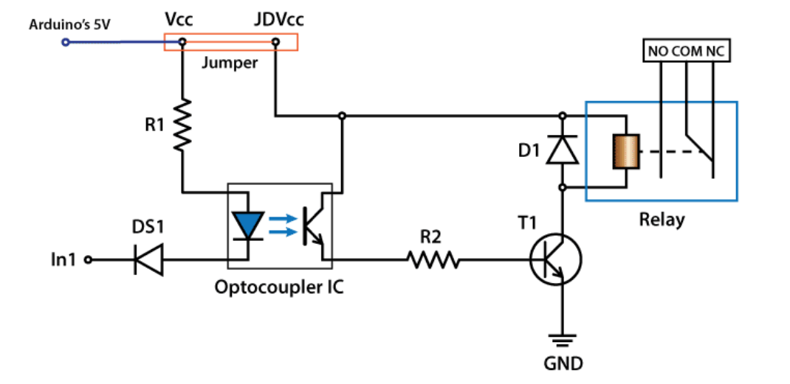

In order to isolate the microcontroller from the relay, we need to remove the jumper and connect separate power supply for the electromagnet to the JDVcc and the Ground pin. Now with this configuration the microcontroller doesn’t have any physical connection with the relay, it just uses the LED light of the Optocoupler IC to activate the relay.

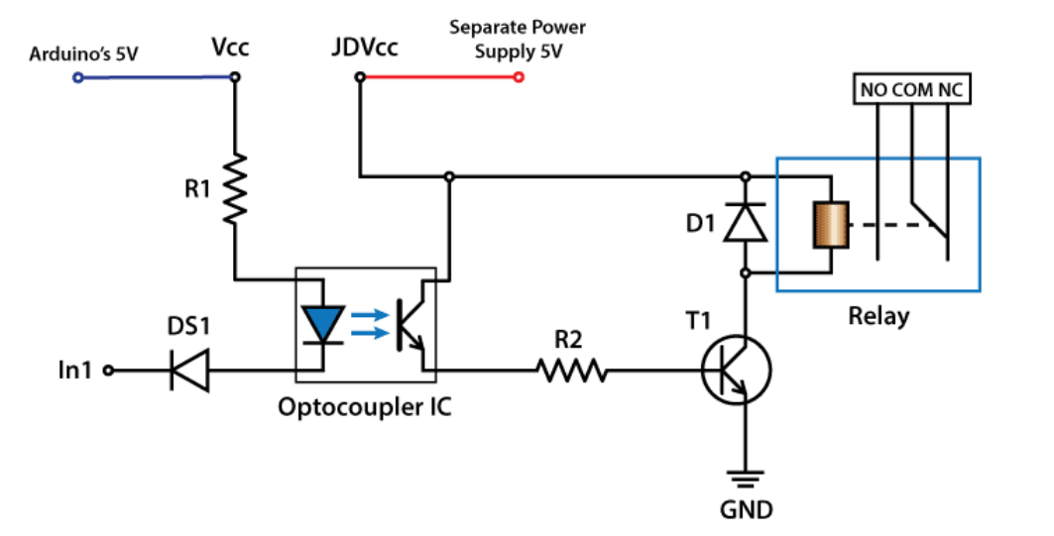

There is one more thing to be noticed from this circuit schematics. The input pins of the module work inversely. As we can see the relay will be activated when the input pin will be LOW because in that way the current will be able to flow from the VCC to the input pin which is low or ground, and the LED will light up and active the relay. When the input pin will be HIGH there will be no current flow, so the LED will not light up and the relay will not be activated

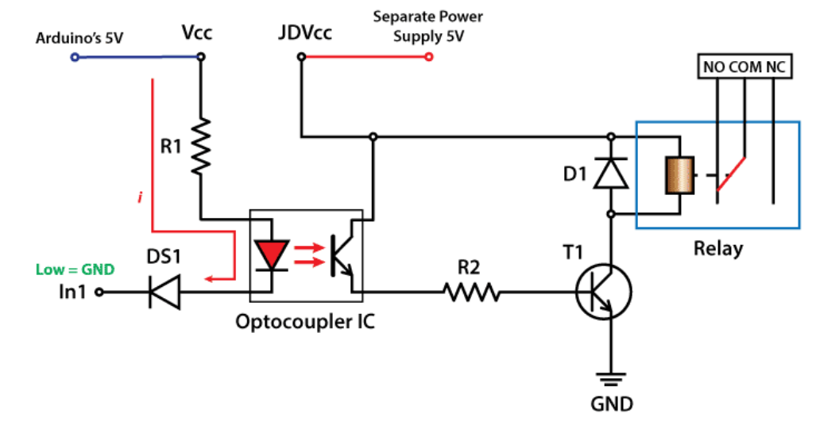

First let’s take a look at the circuit diagram. As previously described we will use a 5V Adapter as a separate power supply for the electromagnet connected to the JDVcc and the Ground pin. The Arduino’s 5V pin will be connected to the Vcc pin of the module and the pin number 7 to the In1 input pin for controlling the relay. Now for the HIGH Voltage part we need a power plug, a socket and a cable with two wires. One of the two wires will be cut and connected to the common and the normally open pin of the module output connector. So with this configuration when we will activate the relay we will get the high voltage circuit closed and working.

**BLUETOOTH MODULE(HC-05 Bluetooth Module)**

Bluetooth protocal: Bluetooth Specification v2.0+EDR  
Frequency: 2.4GHz ISM band  
Modulation: GFSK(Gaussian Frequency Shift Keying)  
Emission power: ≤4dBm, Class 2  
Sensitivity: ≤-84dBm at 0.1% BER  
Speed: Asynchronous: 2.1Mbps(Max) / 160 kbps, Synchronous: 1Mbps/1Mbps  
Security: Authentication and encryption  
Profiles: Bluetooth serial port  
Power supply: +3.3VDC 50mA  
Working temperature: -20 ~ +75Centigrade  
Dimension: 26.9mm x 13mm x 2.2 mm

HC‐05 module is an easy to use Bluetooth SPP (Serial Port Protocol) module,designed for  
transparent wireless serial connection setup.The HC-05 Bluetooth Module can be used in a  
Master or Slave configuration, making it a great solution for wireless communication.This serial port bluetooth module is fully qualified Bluetooth V2.0+EDR (Enhanced Data Rate)3Mbps Modulation with complete 2.4GHz radio transceiver and baseband. It uses CSR Bluecore 04‐ External single chip Rluetooth system with CMOS technology and with AFH (Adaptive Frequency Hopping Feature).

Bluetooth Module HC-05  
The Bluetooth module HC-05 is a MASTER/SLAVE module.By default the factory setting is  
SLAVE.The Role of the module (Master or Slave) can be configured only by AT  
COMMANDS.The slave modules cannot initiate a connection to another Bluetooth device, but can accept connections.Master module can initiate a connection to other devices.The user can use it simply for a serial port replacement to establish connection between MCU and GPS, PC to your embedded project, etc.

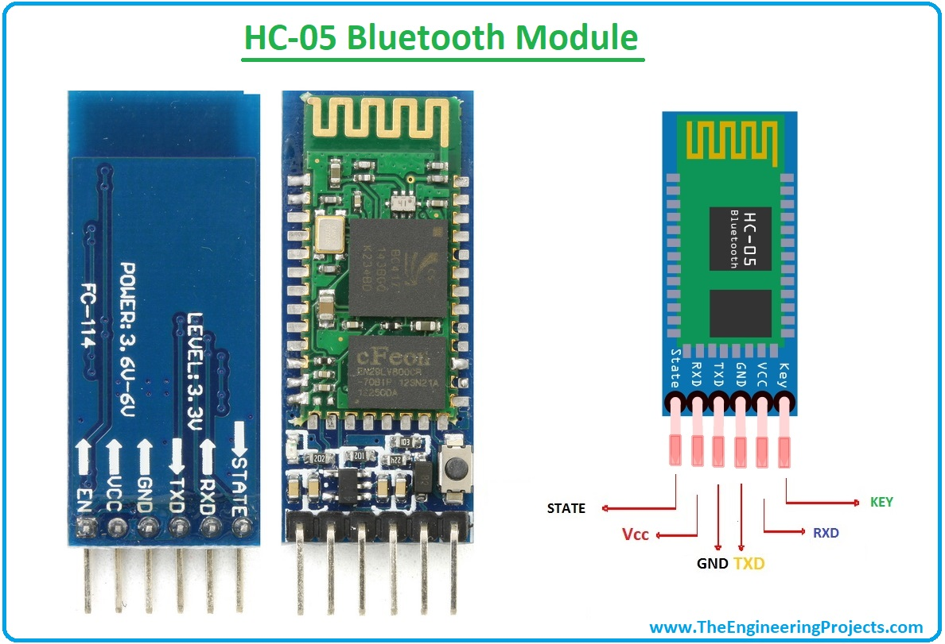

**FIG 3 : PIN DESCRIPTION OF BLUETOOTH MODULE**

**Pin Description:-**The HC-05 Bluetooth Module has 6pins. They are as follows:  
***ENABLE:***When enable is pulled LOW, the module is disabled which means the module will not turn  
on and it fails to communicate.When enable is left open or connected to 3.3V, the module is  
enabled i.e the module remains onand communication also takes place.  
***Vcc:***Supply Voltage 3.3V to 5V  
***GND:***Ground pin  
***TXD & RXD:***These two pins acts as an UART interface for communication  
***STATE:***It acts as a status indicator.When the module is not connected to paired with any other  
bluetooth device,signal goes Low.At this low state,the led flashes continuously which denotes that the module is not paired with other device.When this module is connected to/paired with any other bluetooth device,the signal goes High.At this high state,the led blinks with a constant  
delay say for example 2s delay which indicates that the module is paired.  
***BUTTON SWITCH:***This is used to switch the module into AT command mode.To enable AT command mode,press the button switch for a second.With the help of AT commands,the user can change the parameters of this module but only when the module is not paired with any other BT device.If the module is connected to any other bluetooth device, it starts to communicate with that device and fails to work in AT command mode.

***HC-05 Default Settings:-***Default Bluetooth Name: ‚HC-05‛  
Default Password: 1234 or 0000  
Default Communication: Slave  
Default Mode: Data Mode  
Data Mode Baud Rate: 9600, 8, N, 1  
Command Mode Baud Rate: 38400, 8, N, 1  
Default firmware: LINVOR

**BLOCK DIAGRAM**

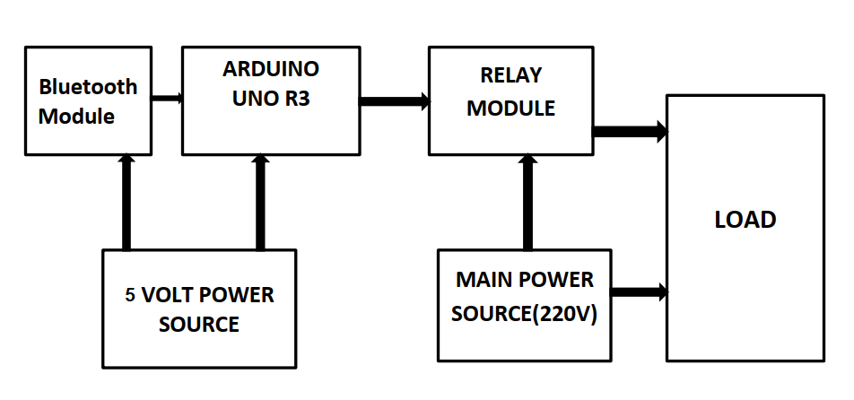

**FIG 4: BLOCK DIAGRAM OF HOME AUTOMATION SYSTEM USING ARDUINO AND BLUETOOTH MODULE**

**CIRCUIT DIAGRAM**

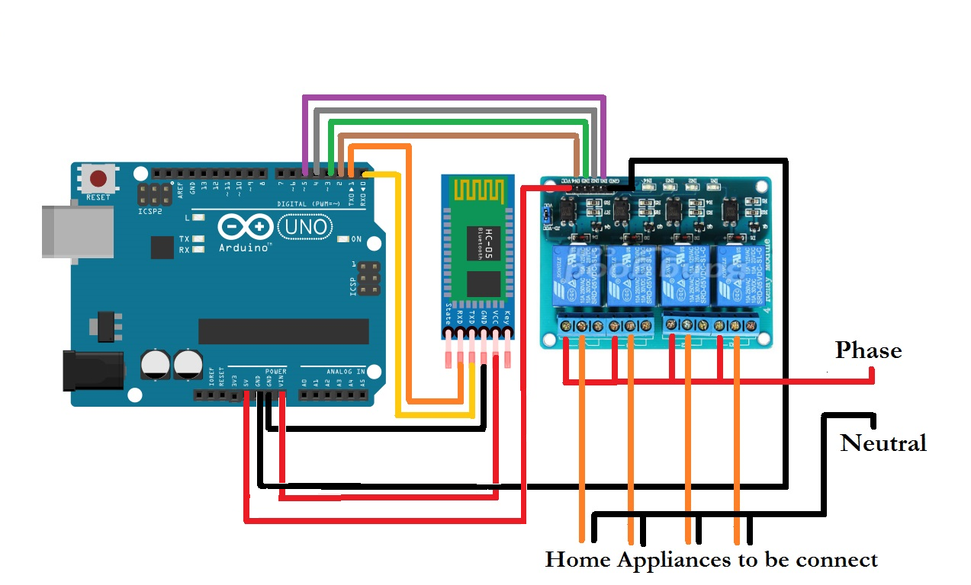

**FIG 5: CIRCUIT DIAGRAM OF HOME AUTOMATION SYSTEM USING ARDUINO AND BLUETOOTH MODULE**

**SOFTWARE DESIGN**

Using MIT App Inventor we design the application which is control by Bluetooth. In this application there are 8 button or 8 channel really will connect in this app. First in smart phone turn on Bluetooth then connect with HC-05 Bluetooth module the when click user any button the it send a letter this letter check in arduino code that it is capital or small latter when capital latter than it trun on the device and when small letter this time turn off the device . Another feather is timer, user can set time when off the device.

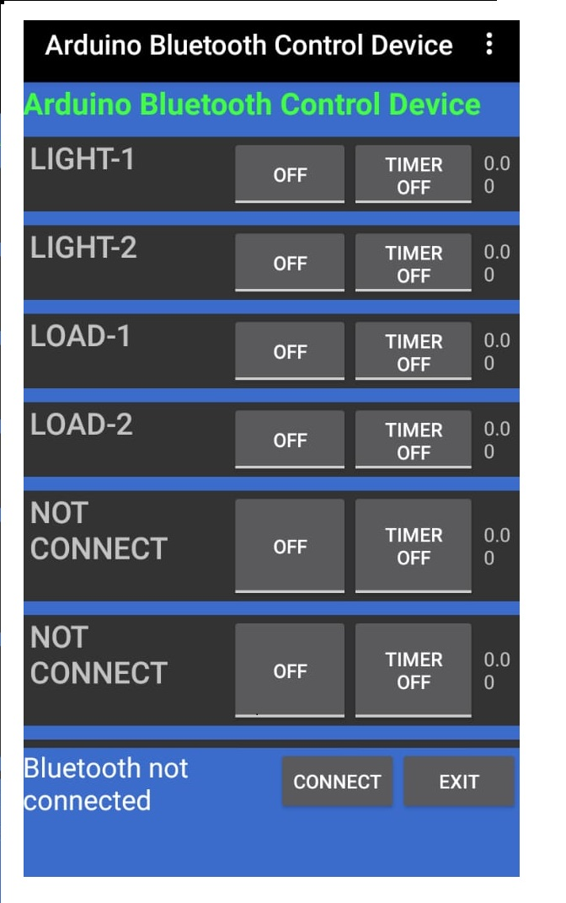

**FIG 6: Design of the software**

**CODE**

String inputs;

#define relay1 2 //Connect relay1 to pin 9

#define relay2 3 //Connect relay2 to pin 8

#define relay3 4 //Connect relay3 to pin 7

#define relay4 5 //Connect relay4 to pin 6

#define relay5 6 //Connect relay5 to pin 5

#define relay6 7 //Connect relay6 to pin 4

#define relay7 8 //Connect relay7 to pin 3

#define relay8 9 //Connect relay8 to pin 2

void setup()

{

Serial.begin(9600); //Set rate for communicating with phone

pinMode(relay1, OUTPUT); //Set relay1 as an output

pinMode(relay2, OUTPUT); //Set relay2 as an output

pinMode(relay3, OUTPUT); //Set relay1 as an output

pinMode(relay4, OUTPUT); //Set relay2 as an output

pinMode(relay5, OUTPUT); //Set relay1 as an output

pinMode(relay6, OUTPUT); //Set relay2 as an output

pinMode(relay7, OUTPUT); //Set relay1 as an output

pinMode(relay8, OUTPUT); //Set relay2 as an output

digitalWrite(relay1, LOW); //Switch relay1 off

digitalWrite(relay2, LOW); //Swtich relay2 off

digitalWrite(relay3, LOW); //Switch relay1 off

digitalWrite(relay4, LOW); //Swtich relay2 off

digitalWrite(relay5, LOW); //Switch relay1 off

digitalWrite(relay6, LOW); //Swtich relay2 off

digitalWrite(relay7, LOW); //Switch relay1 off

digitalWrite(relay8, LOW); //Swtich relay2 off

}

void loop()

{

while(Serial.available()) //Check if there are available bytes to read

{

delay(10); //Delay to make it stable

char c = Serial.read(); //Conduct a serial read

if (c == '#'){

break; //Stop the loop once # is detected after a word

}

inputs += c; //Means inputs = inputs + c

}

if (inputs.length() >0)

{

Serial.println(inputs);

if(inputs == "a")

{

digitalWrite(relay1, LOW);

}

else if(inputs == "A")

{

digitalWrite(relay1, HIGH);

}

else if(inputs == "b")

{

digitalWrite(relay2, LOW);

}

else if(inputs == "A")

{

digitalWrite(relay2, HIGH);

}

else if(inputs == "c")

{

digitalWrite(relay3, LOW);

}

else if(inputs == "C")

{

digitalWrite(relay3, HIGH);

}

else if(inputs == "d")

{

digitalWrite(relay4, LOW);

}

else if(inputs == "D")

{

digitalWrite(relay4, HIGH);

}

else if(inputs == "e")

{

digitalWrite(relay5, LOW);

}

else if(inputs == "E")

{

digitalWrite(relay5, HIGH);

}

else if(inputs == "f")

{

digitalWrite(relay6, LOW);

}

else if(inputs == "F")

{

digitalWrite(relay6, HIGH);

}

else if(inputs == "g")

{

digitalWrite(relay7, LOW);

}

else if(inputs == "G")

{

digitalWrite(relay7, HIGH);

}

else if(inputs == "h")

{

digitalWrite(relay8, LOW);

}

else if(inputs == "H")

{

digitalWrite(relay8, HIGH);

}

inputs="";

}

}

**CONCLUSION**

The system as the name indicates, ‘Smart Home Automation’ makes the system more flexible and provides attractive user interface compared to other home automation systems. In this system we integrate mobile devices into home automation systems. A novel architecture for a home automation system is proposed using the relatively new communication technologies. The system consists of mainly three components is a BLUETOOTH module, Arduino microcontroller and relay circuits. WIFI is used as the communication channel between android phone and the Arduino microcontroller. We hide the complexity of the notions involved in the home automation system by including them into a simple, but comprehensive set of related concepts. This simplification is needed to fit as much of the functionality on the limited space offered by a mobile device’s display. This paper proposes a low cost, secure, ubiquitously accessible, auto-configurable, remotely controlled solution.

The approach discussed in the paper is novel and has achieved the target to control home appliances remotely using the WiFi technology to connects system parts, satisfying user needs and requirements. WiFi technology capable solution has proved to be controlled remotely, provide home security and is costeffective as compared to the previously existing systems. Hence we can conclude that the required goals and objectives of home automation system have been achieved. The system design and architecture were discussed, and prototype presents the basic level of home appliance control and remote monitoring has been implemented. Finally, the proposed system is better from the scalability and flexibility point of view than the commercially available home automation systems.

**REFERENCE**

**1.**Wikipedia  
**2.** Wireless Sensor Networks: Concepts, Applications, Experimentation and Analysis. 2016.  
p. 108. ISBN 9811004129. The use of standardized, with open standards over proprietary  
protocols provides the industry with the freedom to choose between suppliers with guaranteed  
interoperability. Standardized solutions usually have a much longer lifespan than proprietary  
solutions.  
**3**.Jump up^ "Research and Markets: Global Home Automation and Control Market 2014-2020 -  
Lighting Control, Security & Access Control, HVAC Control Analysis of the $5.77 Billion  
Industry". Reuters. 2015-01-19. Archived from the original on 2016-05-05.  
**4.** Home Automation & Wiring (1 ed.). New York: McGraw-Hill/TAB Electronics. 1999-03-  
31. ISBN 9780070246744.